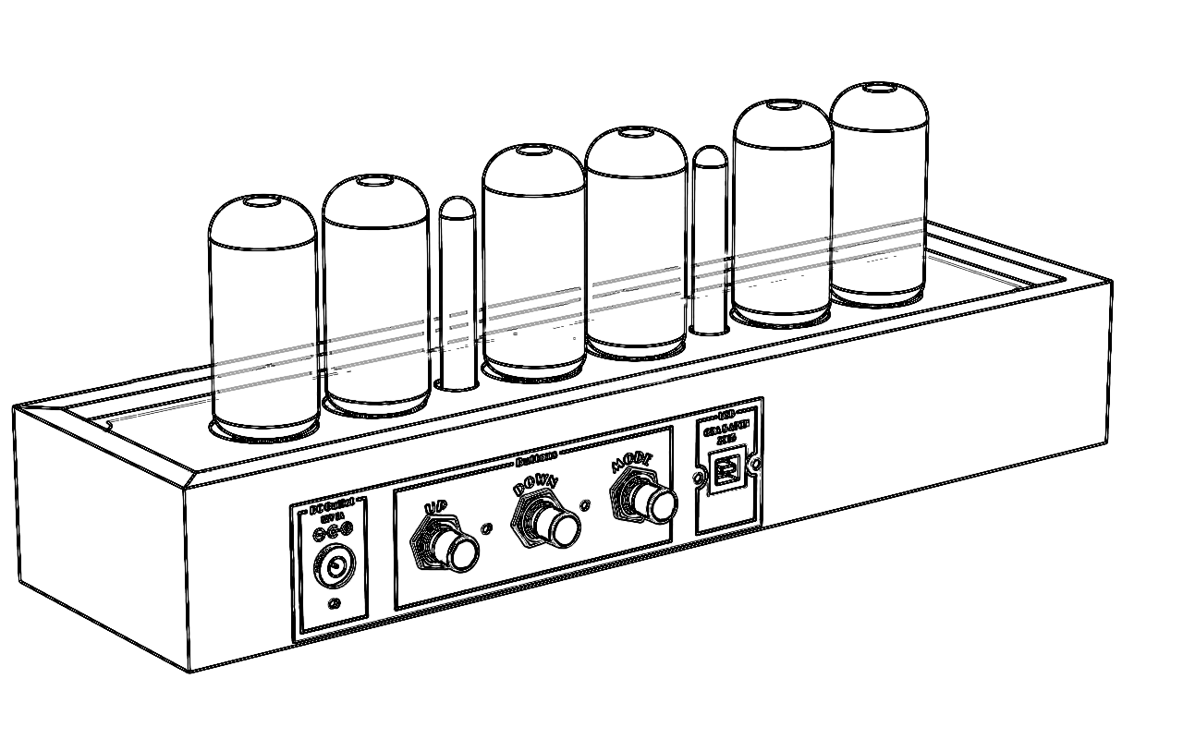

Divergence Meter

Nixie Tubes Clock

Operating instruction

2036

Release 1.5

Gra & AFCH

**GENERAL GUIDE**

1. Press “Mode” to change from mode to mode. Each mode is explained in detail on the following pages.



**TIMEKEEPING MODE**

**To set the digital time**

1. Hold down “Mode” while in the Timekeeping Mode until the hours digits start to flash. The hours flash because they *are selected*.
2. Press “Mode” to change the selection in the following sequence:

* Once you reach the Timekeeping display, you have to hold down “Mode” again to display flashing hours.
* While the digits are selected (flashing), hold down “Mode” to return to Timekeeping Mode without saving.

1. While any digits are selected, press “Up” to increase the number, or “Down” to decrease the number. Holding down “Up” or “Down” changes the current selection at high speed.
2. After you set the time, press “Mode” to select the Timekeeping Mode.

* If you do not operate any button for a few minutes while selection is flashing, the flashing stops and the clock goes back to the Timekeeping Mode automatically.

**DATE MODE**

**To set the date**

1. Hold down “Mode” while in the Date Mode until the all digits start to flash.
2. Press “Mode” to change selection in following sequence:

* While the digits are selected (flashing), hold down “Mode” to return to Timekeeping Mode without saving.

1. Press “UP” or “Down” button to switch between dd/mm (31/12/99) format and mm/dd (12/31/99) format.
2. While any digits are selected, press “Up” to increase the number, or “Down” to decrease the number. Holding down “Up” or “Down” changes the current selection at high speed.
3. After you set the date, press “Mode” to select the Date Mode.

* If you do not operate ant button for a few minutes while a selection is flashing, the flashing stops and clock goes back to the Date Mode automatically.
* The clock does make validation for correct date. So clock not to return to Date Mode if date is incorrect.

**ALARM MODE**

When the Daily Alarm Function is switched on, the alarm sounds at the preset time each day. Press any button to stop the alarm after it starts to sound.

**To set the alarm time**

1. Hold down “Mode” while in Alarm Mode until the hour digits start to flash. The hour digits flash because they are *selected*.
2. Press “Mode” to change selection in the following *sequence*.
3. Press “Up” or “Down” buttons to increase or decrease selected digits. Holding down buttons changes the selections at high speed.
4. Daily alarm on/off mode is representing by upper separate dots, press “Up” or “Down” to enable or disable daily alarm.

* *Entering in Alarm Mode always switch daily alarm on.*
* *If you do not operate any buttons a few minutes while a selection is flashing, the flashing stops and the clock goes to the Timekeeping Mode.*

**12/24 Hours Mode**

**To change 12/24 mode**

1. Enter in 12/24 mode settings, by holding down “Mode” button until 12 or 24 digits start to flash.
2. Press “Up” or “Down” buttons to switch between 12 and 24 modes.
3. After you set time format press “Mode” button to return to Timekeeping mode.

* *If you do not operate any buttons a few minutes while a selection is flashing, the flashing stops and the clock goes to the Timekeeping Mode*

**Temperature Mode**

**To change temperature format Celsius/Fahrenheit or adjust showings of sensor**

1. Select Temperature Mode, pressing the mode button several times...
2. Enter in temperaturemode settings, by holding down “Mode” button until digits start to flash.
3. Press “Up” or “Down” buttons to switch between Celsius and Fahrenheit formats.
4. Press “Mode” button to save settings and return to Temperature mode.

**RGB LED Backlight**

**To disable LED backlight**

1. Hold down “Down” until the LED backlight turns off.

**To enable LED backlight**

1. Hold down “Up” until the LED backlight turns on.

**To fix color of LEDs**

1. Press “Down” button.

**To resume automatic LEDs color changing**

1. Pres “Up” button.

**POWER ON SELF TEST**

Immediately after a clock is powered on Self-Test is starting in the following sequence:

1. Red LEDs on.
2. Green LEDs on.
3. Blue LEDs on.
4. Tubes test which display all digits from 0 to 9 on all tubes simultaneously.
5. Firmware version.
6. Sound test.

web-site: www.gra-afch.com